% Q2 Driver
clear all
close all
clc
x_0 = 1;
y_0 = 1;
x_n = 20;
for i = 1:3
h = 1/2^i;
n = (x_n-x_0)/h;
x = zeros(1,n+1);
y = zeros(1,n+1);
x = x_0:h:x_n;
y(1) = y_0;
for k = 1:n
z = y(k);
y(k+1) = Newton_z(h,z,x(k+1));
end
plot(x,y,'color',rand(1,3))
hold on
end
y_exact = zeros(1,n+1);
y_exact(1) = y_0;
for k = 2:n+1
y_exact(k) = (1+x(k).^2).^(-.5);
end
plot(x,y_exact)
title('Implicit Euler')
axis padded
grid on
xlabel('x')
ylabel('y')
legend('h=0.5','h=0.25','h=0.125','Exact')
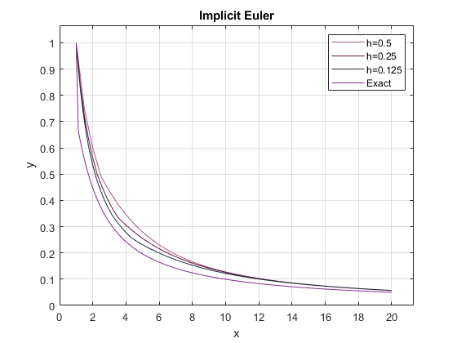
Published with MATLAB® R2021a

